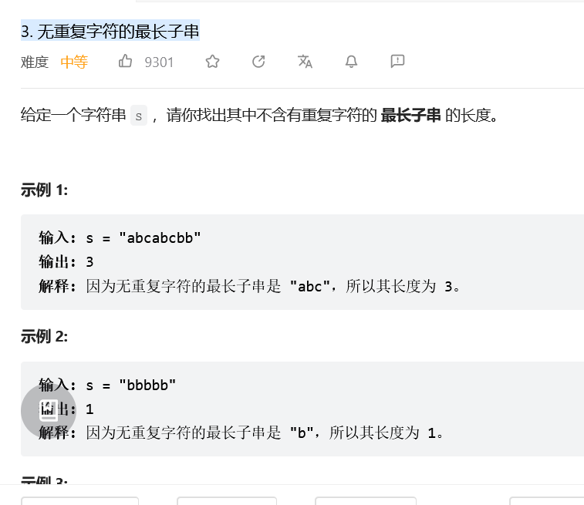滑动窗口
class Solution:
def lengthOfLongestSubstring(self, s: str) -> int:
cur, res = [], 0
for r in range(len(s)):
while s[r] in cur:
cur.pop(0) # 左边出
cur.append(s[r]) # 右侧无论如何都会进入新的
res = max(len(cur),res)
return res
